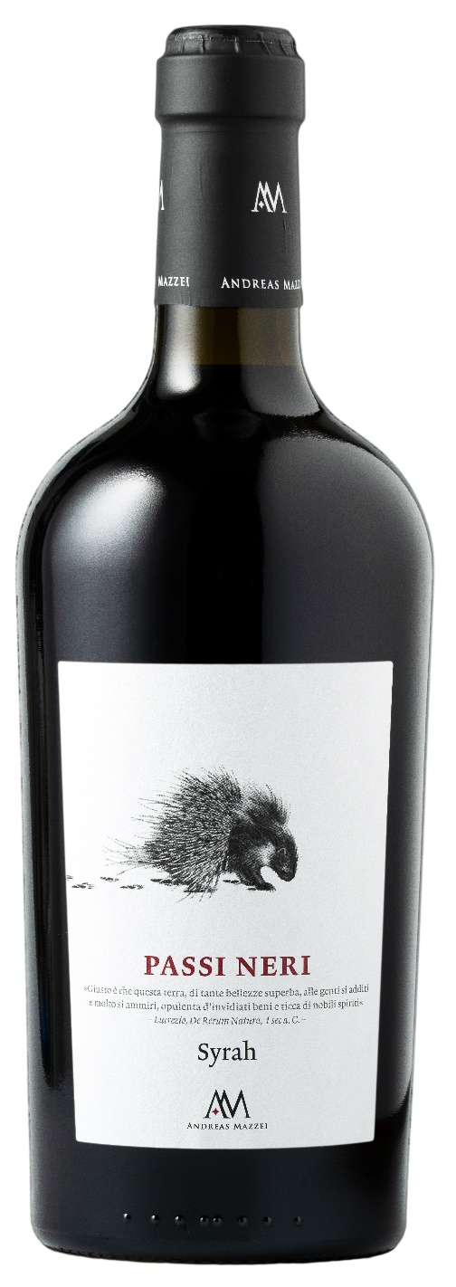
SYRAH IGP – PASSI NERI
Among the black footsteps left by winemakers in the hot Sicilian lands, "PASSI NERI" is born. This wine is the fruit of thousand-year-old winemaking traditions. The optimal position of the terrain and the meticulous attention paid to the vineyards; the ability to wait patiently for the right moment to harvest, letting the sun caress the grapes for as long as possible; these are fundamental elements which make this product so
particular.

Grape: Syrah 100%
Alc. Vol.%: 14,5
Vintage: 2024
Residual sugar g/l: 7,5
Total acidity g/l: 5,7
Region: Sicily
Production zone: Vineyards in Western Sicily
Capacity: 750ml

CHARACTERISTICS

Vinification: Fermentation in steel tanks at a controlled temperature of 26°C for several days of peel maceration
Aging: minimum 8 months in oak and steel
Yield per ha: 10000kg
Colour: Intensive brilliant red
Bouquet: Pleasant notes of wood berries and vanilla
Flavour: Full bodied, complex and smooth

SERVING SUGGESTIONS

Best enjoyed with grilled meat, venison and mature cheese.
Serving temperature 18 °C
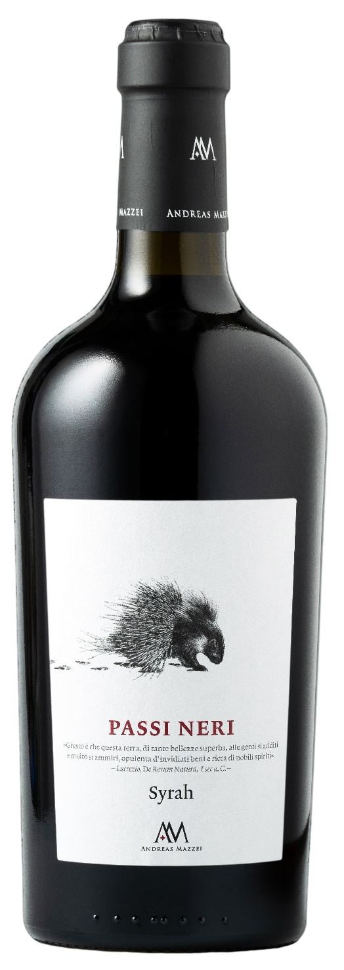
TECHNICAL INFORMATION / PALLETIZING

Size 750ml:
Article Nr. V04002A
GTIN-13 bottle 8017868003564
GTIN-13 carton 8017868003595
Closure Cork
Bottles / carton 6 bottles
Pallet size 80x120cm
Cartons/layer 17
Cartons/pallet 102
Kg/carton 10
Kg/pallet 820

Contains sulphites
GMO Free
Revisione 01. 21.04.2026

